**Lesson 9 Demo 4**

**Node Not Ready**

**Objective:** Learn how to configure a node with the status **NotReady** to **Ready.**

**Tools required:** kubeadm and kubectl

**Prerequisites:** Follow lesson 2 demo 1 to set up a Kubernetes cluster.

Steps to be followed:

1. Checking the node status on the master node
2. Navigating to worker-node2
3. Stopping the Docker service and checking the kubelet status
4. Navigating to the master node and checking the node status
5. Restarting the Docker service on worker-node2
6. Verifying the node status on the master node

**Step 1: Checking the node status on the master node**

1. Check the node status on the master node by using the following command:

**kubectl get nodes**

**Step 2: Navigating to worker-node2**

1. Go to the worker-node2.example.com:

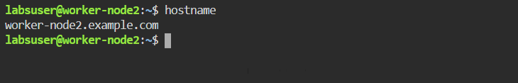

**Step 3: Stopping the Docker service and checking the kubelet status**

1. Stop the Docker service to introduce the error and check the kubelet status by running the following commands:

**sudo systemctl stop docker.socket**

**sudo systemctl stop docker**

**sudo systemctl daemon-reload**

**sudo systemctl restart kubelet**

**sudo systemctl status kubelet**

**Step 4: Navigating to the master node and checking the node status**

1. Check the node status on the master node using the following command:

**kubectl get nodes**

**Step 5: Restarting the Docker service on worker-node2**

1. To solve the error, restart the Docker service by running the following commands on worker-node2:

**sudo systemctl restart docker.socket**

**sudo systemctl restart docker**

**sudo systemctl daemon-reload**

**sudo systemctl restart kubelet**

**sudo systemctl status kubelet**

**Step 6: Verifying the node status on the master node**

1. Check the node status on the master node using the following command:

**kubectl get nodes**

Hence, configuring a node with the status **NotReady** to **Ready** has been completed successfully.